**HTML & CSS TASK**

**Question1:**

1. **Fix the bugs in below snippet**

**<html lang="en">**

**<head>**

**<title>Document**

**<body>**

**guvi**

**</title>**

**</head>**

**<div>**

**Lorem ipsum dolor sit amet consectetur adipisicing elit.**

**<div>**

**<div>**

**Guvi Geek Network**

**</div>**

**</body>**

**</html>**

**Code:**

<html lang="en">

  <head>

      <title>Document

      </title>

  </head>

  <body>

    guvi

  <div>

      Lorem ipsum dolor sit amet consectetur adipisicing elit.

      <div>

          <div>

              Guvi Geek Network

          </div>

          </div>

          </div>

      </body>

  </html>

Ouput screenshot:

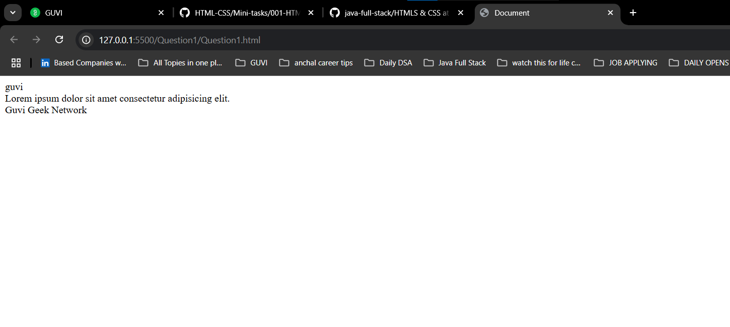

QUESTION2:

1. Try the below one

<html lang="en">

<head>

<title>Document

<body>

guvi

</head>

<div>

Lorem ipsum dolor sit amet consectetur adipisicing elit.

<div>

<div>

Guvi Geek Network

</div>

</body>

</html>

CODE:

<html lang="en">

    <head>

        <title>Document </title>

    </head>

    <body>

      guvi

    <div>

        Lorem ipsum dolor sit amet consectetur adipisicing elit.

        <div>

            <div>

                Guvi Geek Network

            </div>

        </div>

    </div>

     </body>

    </html>

OUTPUT:

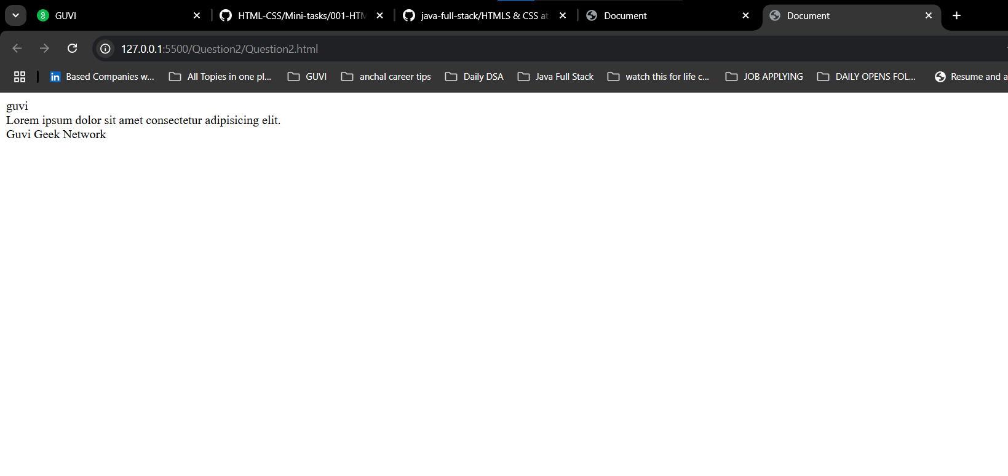

QUESTION 3:

1. Design a contact us form with all fields as required.

CODE:

  <!DOCTYPE html>

  <html lang="en">

  <head>

    <meta charset="UTF-8">

    <meta name="viewport" content="width=device-width, initial-scale=1.0">

    <link rel="stylesheet" href="Style.css">

    <title>Document</title>

  </head>

  <body>

    <form class="contact-form">

      <h2>Contact Us</h2>

      <label for="name">Full Name</label>

      <input type="text" id="name" name="name" required>

      <label for="email">Email Address</label>

      <input type="email" id="email" name="email" required>

      <label for="phone">Phone Number</label>

      <input type="tel" id="phone" name="phone" required>

      <label for="message">Message</label>

      <textarea id="message" name="message" rows="4" required></textarea>

      <button type="submit">Send Message</button>

  </form>

  </body>

  </html>

body {

  font-family: Arial, sans-serif;

  background: #f9f9f9;

  display: flex;

  justify-content: center;

  align-items: center;

  height: 100vh;

}

.contact-form {

  background: #fff;

  padding: 30px;

  border-radius: 12px;

  box-shadow: 0 4px 8px rgba(0,0,0,0.1);

  width: 400px;

}

.contact-form h2 {

  text-align: center;

  margin-bottom: 20px;

  color: #333;

}

.contact-form label {

  display: block;

  margin-bottom: 5px;

  font-weight: 600;

}

.contact-form input,

.contact-form textarea {

  width: 100%;

  padding: 10px;

  margin-bottom: 15px;

  border: 1px solid #ccc;

  border-radius: 8px;

}

.contact-form button {

  width: 100%;

  padding: 12px;

  background-color: #007BFF;

  color: white;

  font-size: 16px;

  border-radius: 8px;

  cursor: pointer;

}

.contact-form button:hover {

  background-color: #0056b3;

}

OUTPUT SCREEN SHOT:

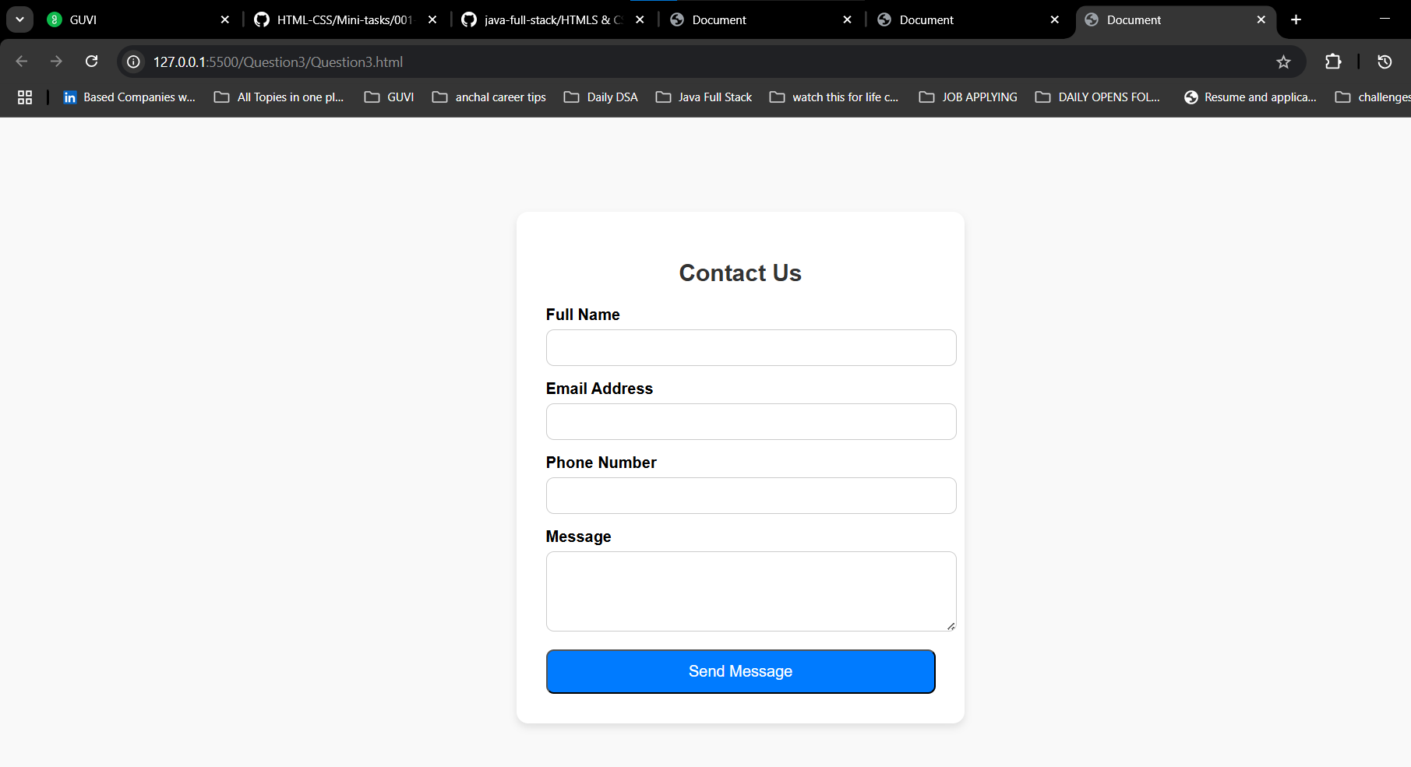

QUESTION 4:

1. Use certain HTML elements to display the following in a HTML page.

* Programming Language
  + JavaScript
    1. Angular
    2. React
    3. Vue.js
  + Python
    1. Django Framework
    2. Flask Framework
  + Java
    1. Spring
    2. Maven
    3. Hibernate
* Database
  + MySQL
  + MongoDB
  + Cansandra

CODE:

<!DOCTYPE html>

<html lang="en">

<head>

    <meta charset="UTF-8">

    <title>Technology Categories</title>

</head>

<body>

    <ul>

        <li>Programming Language

            <ul>

                <li>JavaScript

                    <ol type="a">

                        <li>Angular</li>

                        <li>React</li>

                        <li>Vue.js</li>

                    </ol>

                </li>

                <li>Python

                    <ol type="a">

                        <li>Django Framework</li>

                        <li>Flask Framework</li>

                    </ol>

                </li>

                <li>Java

                    <ol type="a">

                        <li>Spring</li>

                        <li>Maven</li>

                        <li>Hibernate</li>

                    </ol>

                </li>

            </ul>

        </li>

        <li>Database

            <ul>

                <li>MySQL</li>

                <li>MongoDB</li>

                <li>Cassandra</li>

            </ul>

        </li>

    </ul>

</body>

</html>

OUTPUT:

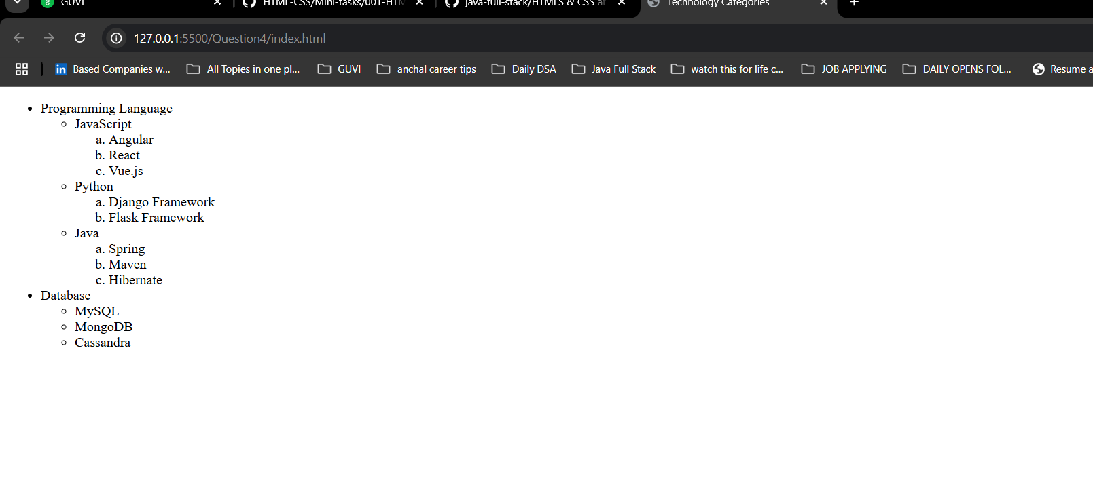

QUESTION 5:

1. Create an element that helps you to open the [https://google.com](https://google.com/) in separate new tab.

CODE:

<!DOCTYPE html>

<html lang="en">

<head>

  <meta charset="UTF-8">

  <meta name="viewport" content="width=device-width, initial-scale=1.0">

  <title>Document</title>

</head>

<body>

  <a href="https://google.com/" target="_blank"> google</a>

</body>

</html>

OUTPUT:

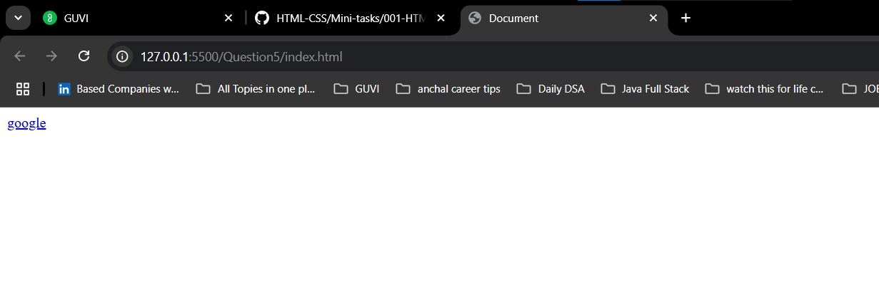

QUESTION 6:

1. In the form, add two radio buttons with grouping them for employee type(Salaried and own business)

CODE:

<!DOCTYPE html>

<html lang="en">

<head>

    <meta charset="UTF-8">

    <title>Contact Us</title>

      <link rel="stylesheet" href="Style.css">

</head>

<body>

  <form>

    <h2>Contact Us</h2>

    <label for="name">Full Name:</label>

    <input type="text" id="name" name="name" required>

    <label for="email">Email Address:</label>

    <input type="email" id="email" name="email" required>

    <label for="phone">Phone Number:</label>

    <input type="tel" id="phone" name="phone" required>

    <label for="subject">Subject:</label>

    <input type="text" id="subject" name="subject" required>

    <label for="message">Message:</label>

    <textarea id="message" name="message" rows="4" required></textarea>

    <label>Employee Type:</label>

    <div class="radio-group">

        <input type="radio" id="salaried" name="employeeType" value="Salaried" required>

        <label for="salaried">Salaried</label>

        <input type="radio" id="business" name="employeeType" value="Own Business" required>

        <label for="business">Own Business</label>

    </div>

    <button type="submit" class="submit-btn">Send Message</button>

</form>

</body>

</html>

body {

  font-family: Arial, sans-serif;

  background-color: #eef2f3;

  display: flex;

  justify-content: center;

  align-items: center;

  height: 100vh;

}

form {

  background: #fff;

  padding: 30px;

  border-radius: 12px;

  box-shadow: 0 4px 12px rgba(0, 0, 0, 0.1);

  width: 400px;

}

h2 {

  text-align: center;

  margin-bottom: 20px;

}

label {

  display: block;

  margin-top: 10px;

  font-weight: bold;

}

input[type="text"],

input[type="email"],

input[type="tel"],

textarea {

  width: 100%;

  padding: 10px;

  margin-top: 5px;

  margin-bottom: 15px;

  border: 1px solid #ccc;

  border-radius: 8px;

  box-sizing: border-box;

}

textarea {

  resize: vertical;

}

.radio-group {

  margin-bottom: 15px;

}

.radio-group label {

  font-weight: normal;

  margin-right: 10px;

}

.submit-btn {

  background-color: #007bff;

  color: white;

  border: none;

  padding: 12px;

  width: 100%;

  border-radius: 8px;

  font-size: 16px;

  cursor: pointer;

}

.submit-btn:hover {

  background-color: #0056b3;

}

OUTPUT :

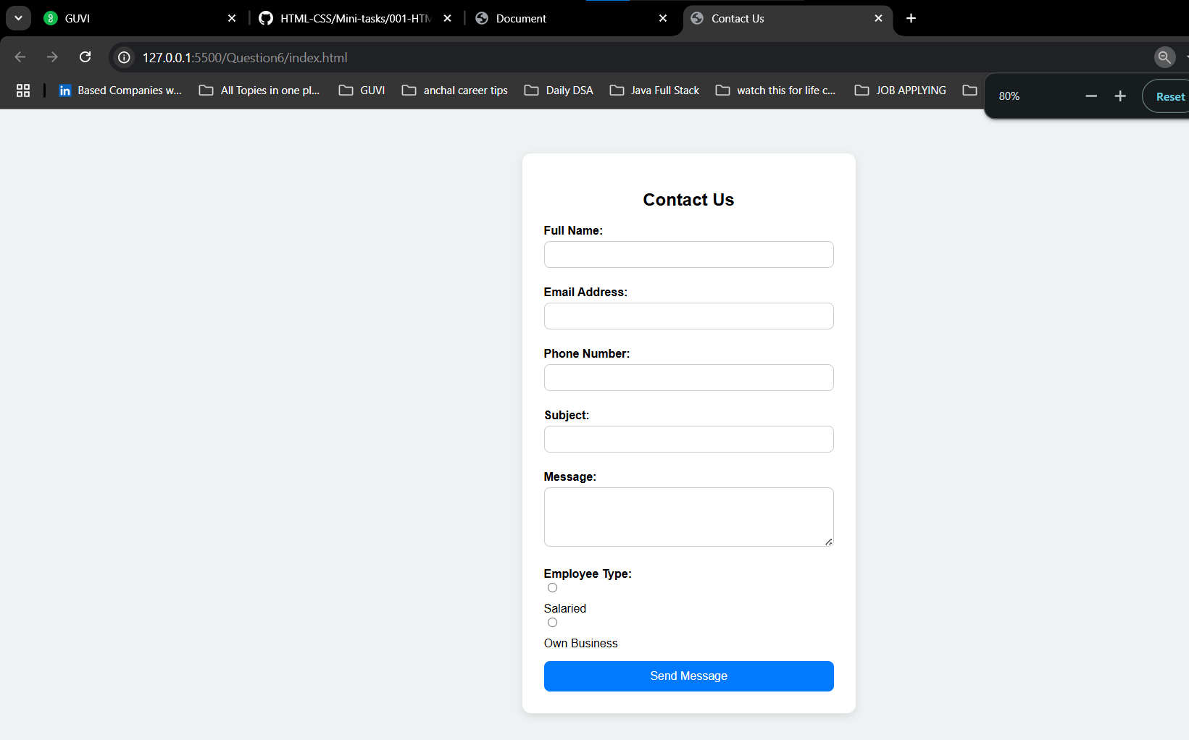

QUESTION 9

1. Write HTML input tags snippet to show default values for all Form elements.

CODE:

<!DOCTYPE html>

<html lang="en">

<head>

  <meta charset="UTF-8">

  <meta name="viewport" content="width=device-width, initial-scale=1.0">

  <title>QUestion9

  </title>

</head>

<body>

  <form>

    <!-- Text Input -->

    <label for="name">Name:</label>

    <input type="text" id="name" name="name" value="Thrivendra"><br><br>

    <!-- Email Input -->

    <label for="email">Email:</label>

    <input type="email" id="email" name="email" value="Thrivendra@example.com"><br><br>

    <!-- Number Input -->

    <label for="age">Age:</label>

    <input type="number" id="age" name="age" value="24"><br><br>

    <!-- Phone Input -->

    <label for="phone">Phone:</label>

    <input type="tel" id="phone" name="phone" value=""><br><br>

    <!-- Password Input -->

    <label for="password">Password:</label>

    <input type="password" id="password" name="password" value=""><br><br>

    <!-- Textarea -->

    <label for="message">Message:</label><br>

    <textarea id="message" name="message" rows="4" cols="30">Hello, this is a default message.</textarea><br><br>

    <!-- Radio Buttons -->

    <label>Gender:</label><br>

    <input type="radio" id="male" name="gender" value="" >

    <label for="male">Male</label>

    <input type="radio" id="female" name="gender" value="">

    <label for="female">Female</label><br><br>

    <!-- Checkbox -->

    <label>

      <input type="checkbox" name="subscribe" >

      Subscribe to newsletter

    </label><br><br>

    <!-- Dropdown -->

    <label for="country">Country:</label>

    <select id="country" name="country">

      <option value="india" selected  >India</option>

      <option value="usa" >USA</option>

      <option value="uk">UK</option>

    </select><br><br>

    <!-- Submit Button -->

    <button type="submit">Submit</button>

  </form>

</body>

</html>

OUTPUT:

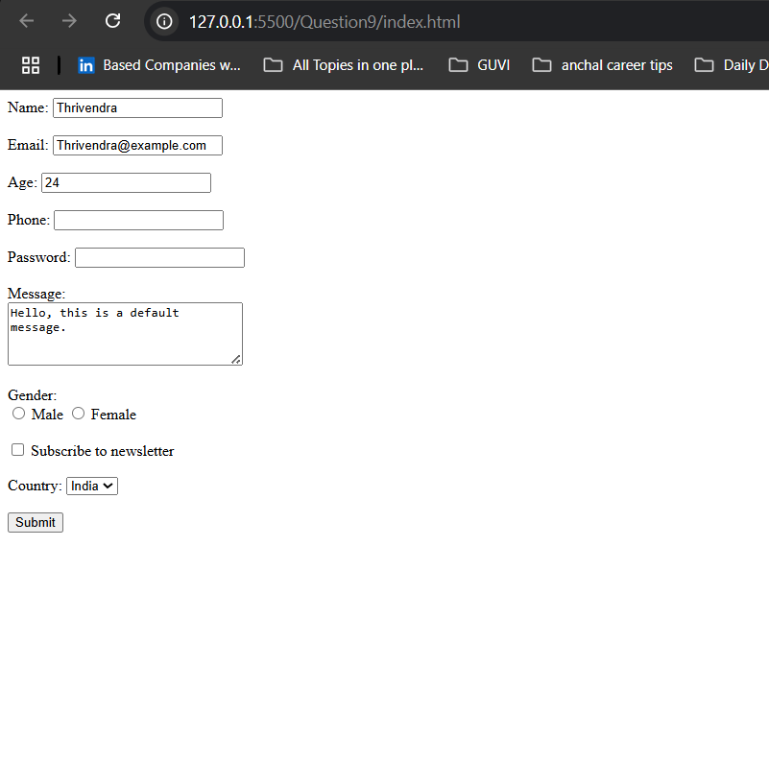

QUESTION 10

1. In your, HTML page add the below line and Highlight it without using any CSS.

* "HTML & CSS is awesome"
* <!DOCTYPE html>
* <html lang="en">
* <head>
* <meta charset="UTF-8">
* <meta name="viewport" content="width=device-width, initial-scale=1.0">
* <title>Document</title>
* </head>
* <body>
* <p><mark>HTML &amp; CSS is awesome</mark></p>
* </body>
* </html>

OUPUT:

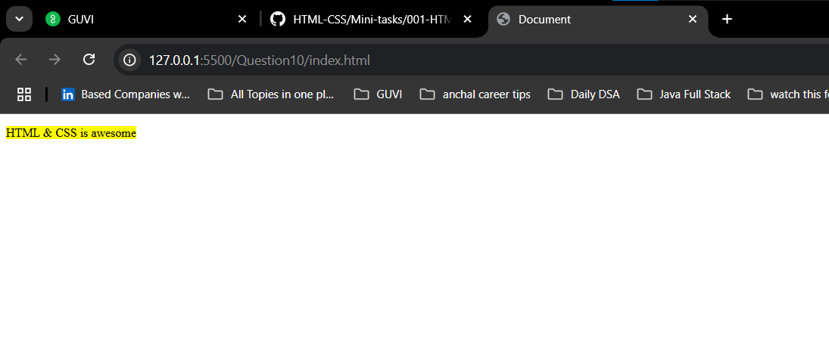

QUESTION 11:

1. Create an HTML page, which should contain all types of input elements.

CODE:

<!DOCTYPE html>

<html lang="en">

<head>

  <meta charset="UTF-8">

  <meta name="viewport" content="width=device-width, initial-scale=1.0">

  <title>Question11</title>

</head>

<body>

  <h1>All Types of Input Elements</h1>

  <form>

    <!-- Text Input -->

    <label for="text">Text:</label>

    <input type="text" id="text" name="text" placeholder="Enter text"><br><br>

    <!-- Password Input -->

    <label for="password">Password:</label>

    <input type="password" id="password" name="password"><br><br>

    <!-- Email Input -->

    <label for="email">Email:</label>

    <input type="email" id="email" name="email"><br><br>

    <!-- Number Input -->

    <label for="number">Number:</label>

    <input type="number" id="number" name="number"><br><br>

    <!-- Tel Input -->

    <label for="tel">Phone Number:</label>

    <input type="tel" id="tel" name="tel"><br><br>

    <!-- URL Input -->

    <label for="url">Website:</label>

    <input type="url" id="url" name="url"><br><br>

    <!-- Search Input -->

    <label for="search">Search:</label>

    <input type="search" id="search" name="search"><br><br>

    <!-- Date Input -->

    <label for="date">Date:</label>

    <input type="date" id="date" name="date"><br><br>

    <!-- Time Input -->

    <label for="time">Time:</label>

    <input type="time" id="time" name="time"><br><br>

    <!-- Week Input -->

    <label for="week">Week:</label>

    <input type="week" id="week" name="week"><br><br>

    <!-- Month Input -->

    <label for="month">Month:</label>

    <input type="month" id="month" name="month"><br><br>

    <!-- Color Input -->

    <label for="color">Color Picker:</label>

    <input type="color" id="color" name="color"><br><br>

    <!-- Radio Buttons -->

    <label>Gender:</label><br>

    <input type="radio" id="male" name="gender" value="male">

    <label for="male">Male</label>

    <input type="radio" id="female" name="gender" value="female">

    <label for="female">Female</label><br><br>

    <!-- Checkboxes -->

    <label>Languages Known:</label><br>

    <input type="checkbox" id="html" name="language" value="HTML">

    <label for="html">HTML</label>

    <input type="checkbox" id="css" name="language" value="CSS">

    <label for="css">CSS</label>

    <input type="checkbox" id="js" name="language" value="JavaScript">

    <label for="js">JavaScript</label><br><br>

    <!-- Select Dropdown -->

    <label for="country">Country:</label>

    <select id="country" name="country">

      <option value="india">India</option>

      <option value="usa">USA</option>

      <option value="uk">UK</option>

    </select><br><br>

    <!-- Textarea -->

    <label for="message">Message:</label><br>

    <textarea id="message" name="message" rows="4" cols="40"></textarea><br><br>

    <!-- File Input -->

    <label for="file">Upload File:</label>

    <input type="file" id="file" name="file"><br><br>

    <!-- Range Slider -->

    <label for="volume">Volume:</label>

    <input type="range" id="volume" name="volume" min="0" max="100"><br><br>

    <!-- Hidden Input -->

    <input type="hidden" name="userId" value="12345">

    <!-- Buttons -->

    <input type="reset" value="Reset">

    <input type="submit" value="Submit">

  </form>

</body>

</html>

